Lesson Two: Why Didn’t You See a Doctor? -- Dialogue
- Warm- up Name: _____________
- Look at the pictures on P. 19 and 20. What can you see? | - Predict what might happen in the dialogue
- What do you do when you have a cold?

- While--listening
- Listen and check what symptoms did Scott have? Answer: _________________
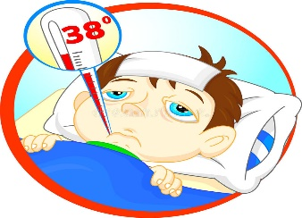

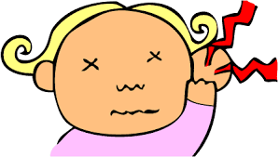

- (B) (C) (D)
(E) (F) (G) (H)

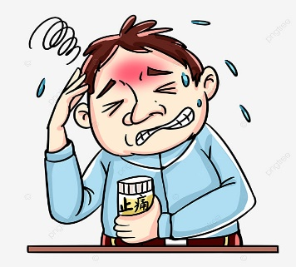

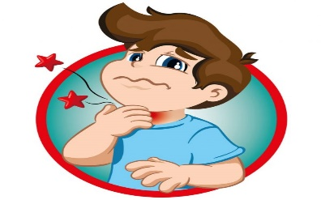

- Listen and check what Scott did to recover from (復原)his cold?
- (B) (C) (D)
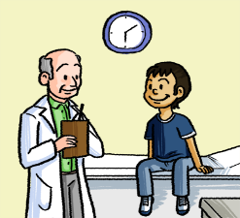
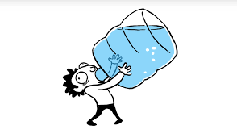
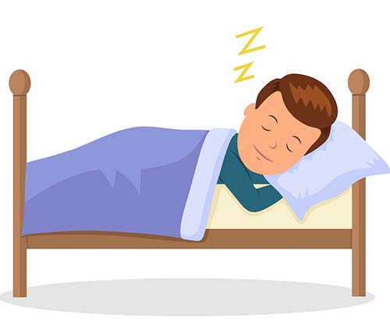


- After--listening
Why didn’t Scott go to work today? →______________________________________________
2. When do people in Scott’s country see a doctor? → __________________________________
3. What can people in Scott’s country do when they have a sore throat? →___________________
4. Do you want to try eating ice cream for your sore throat? →_____________________________

