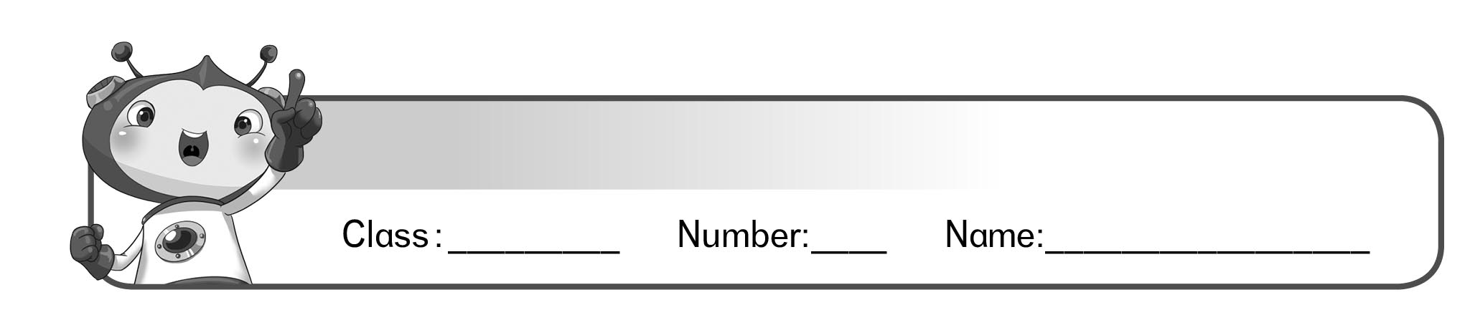
Read and match.
Lesson 3 What’s This?

I am small. I am usually white. I can take away all the mistakes you make with pencils.
1.

• •

2.
I am a rectangle. I am usually made of plastic or metal. You can use me to draw a line or measure things.

• •

I can be big or small. There are words or pictures inside of me. I can teach you a lot of things.
3.

• •

I am thin. You can use me to write or draw. I am afraid of erasers.
4.

• •

國小英語 Follow Me 1 學習單

