南一版:B4—Lesson 4~Dialogue Name Class No.

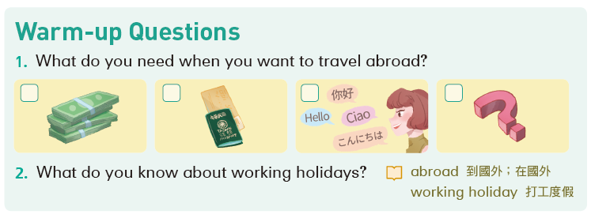

picture 1 picture2
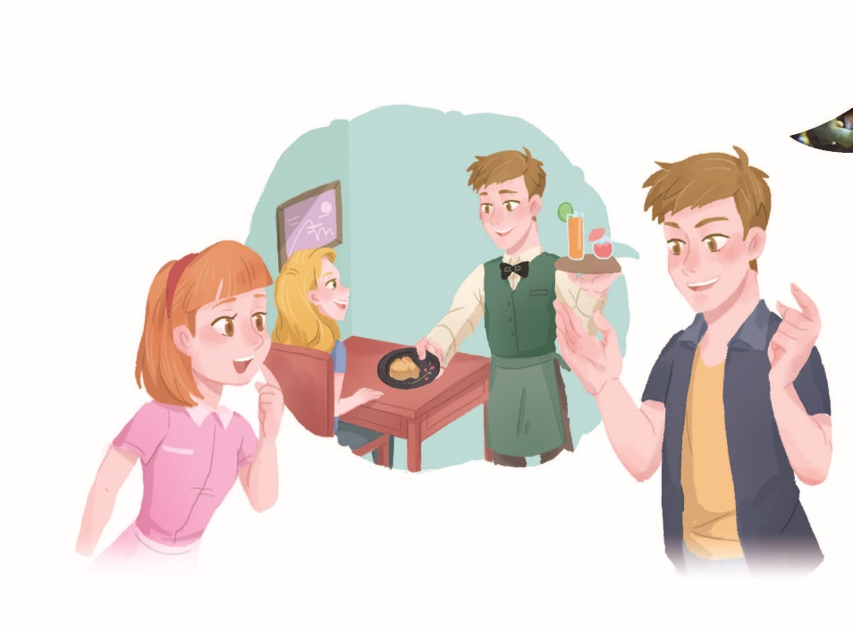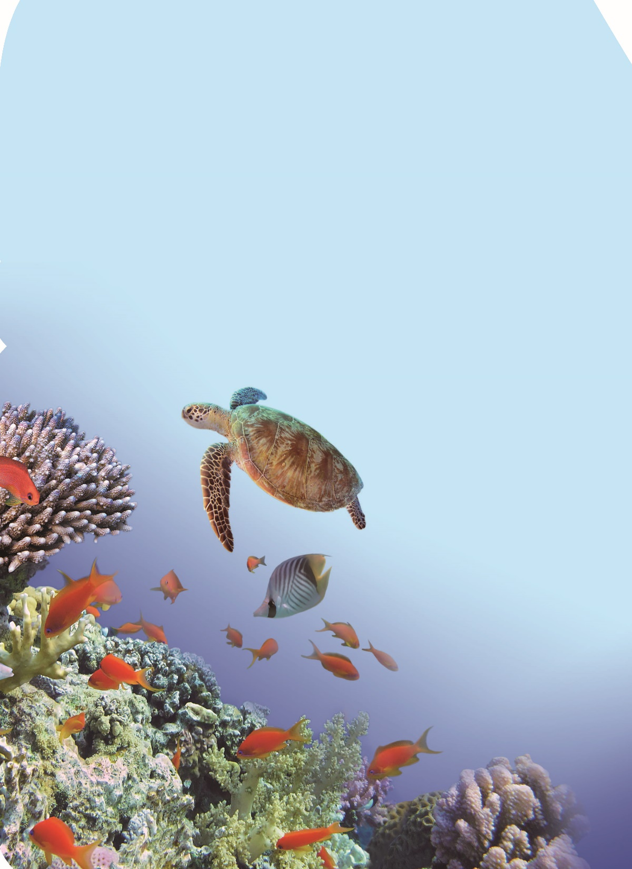

Pre-reading Questions
Write down four questions of your own before you read the dialogue.
Questions | Answers
- What are they talking about? | They are talking about a wrking holiday.
2. Look at pictuer one.  What kind of job did Ian do last year?  Where did he work? | He worked as a waiter in a hotel restaurant in Australia.
3. Look at picture two.  What is the Great Barrier Reef | It’s an amazing place in Australia.

Let’s Listen
Part A：Listen and circle.
Circle the Verbs：請再看一次文本，將文中動詞用紅筆圈出
Unit 4 I want to take a working holiday
Ian is visiting his cousin, Emily
Ian：G’day, Emily. Long time no see.
Emily：Ian! What a surprise! What are you up to these days?
Ian：I went on a working holiday to Australia.
I spent a year working and traveling there.
Emily：Cool. What kind of job did you do?
Ian：I worked as a waiter in a hotel restaurant near the Great Barrier Reef.
Emily：The Great Barrier Reef? How was your life there?
Ian：It was amazing. I enjoyed living there a lot. The air is fresh, and the water is clear. There are colorful coral reefs, cute sea turtles, and beautiful beaches.
Emily：Wow. That’s wonderful. I want to take a working holiday too when I am old enough. What should I do to prepare?
Ian：First, you should keep practicing English.

Part B：Let’s Read together
Part C：Words
Words
1. cousin (n.) 堂、表兄弟姊妹
2. spend (v.) 花費 ( 過去式為spent)
3. job (n.) 工作 4. as (prep.) 以⋯⋯的身分
5. waiter (n.) 男服務生 6. live (v.) 生活；居住
7. air (n.) 空氣；空中 8. fresh (adj.) 新鮮的
9. clear (adj.) 清澈的 10. sea turtle (n.) 海龜
11. beach (n.) 海灘 12. want (v.) 想要
13. should (aux.) 應該 14. prepare (v.) 準備
15. keep (v.) 保持 16. practice (v.) 練習
17. dollar (n.) 元 18. lesson (n.) 課程
① travel (v.) 旅行
② amazing (adj.) 非常好 ; 令人驚喜的
③ coral reef (n.) 珊瑚礁
Give me a break! (phr.) 饒了我吧！
No kidding! (phr.) 不是開玩笑的！

Part D
Dialogue Mind map
Finish the mind map after you read the dialogue.
I want to take a working holiday
Who are talking? | Ian and Emily
What is Ian talking about? | Ian is talking about his experience of taking a working holiday in Australia.
Where did Ian work? | In a restaurant near the Great Barrier Reef
What did Ian do there? | Ian spent a year working and traveling there.
How is the Great Barrier Reef? | The air is fresh, and the water is clear. There are colorful coral reefs, cute sea turtles, and beautiful beaches.
Future plan | Emily wants to take a working holiday,too.

