**Narrative Writing: Comic Strips (1)**

**Class: Number: Name:**

*說明：1.依提示在下方作答區上寫一篇英文作文。*

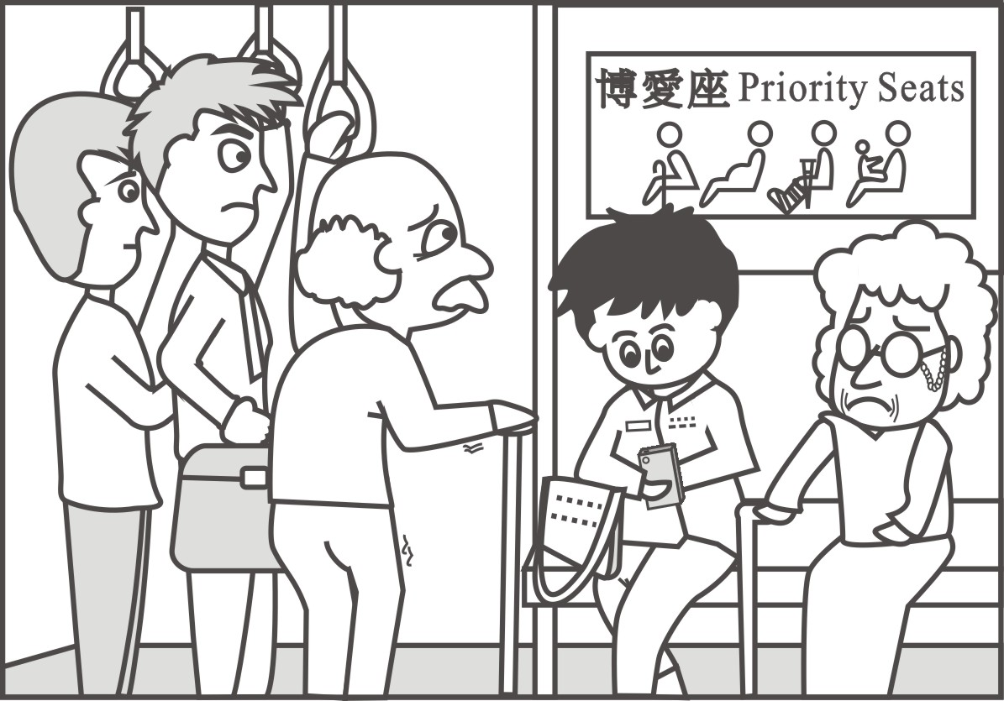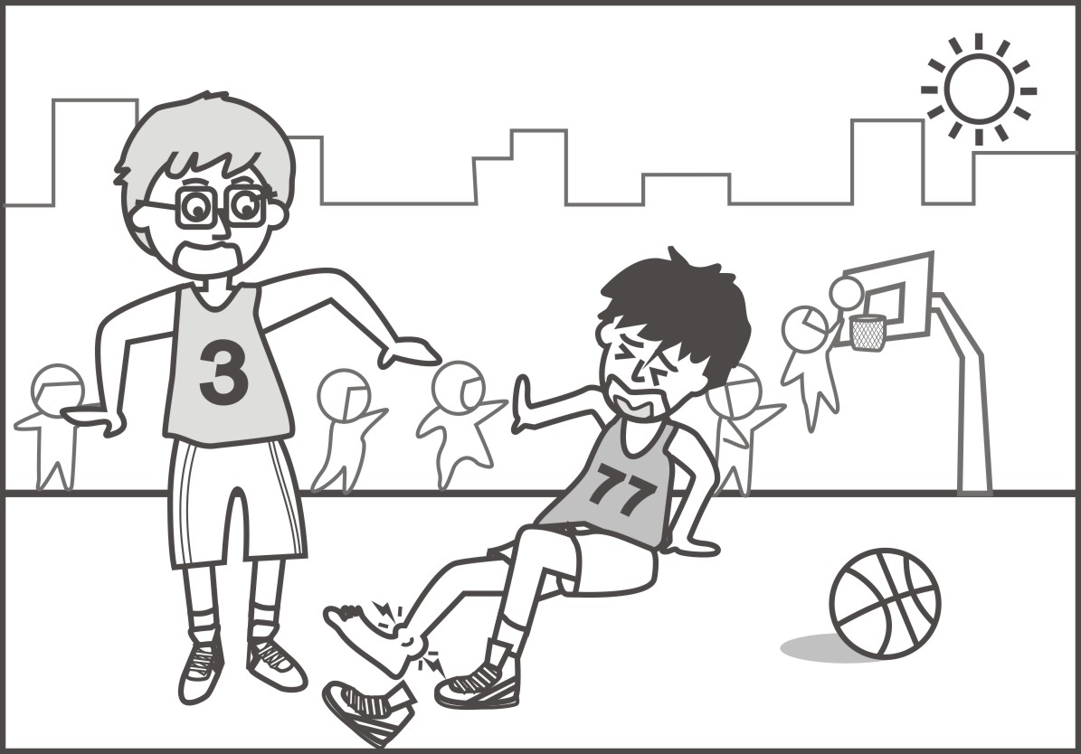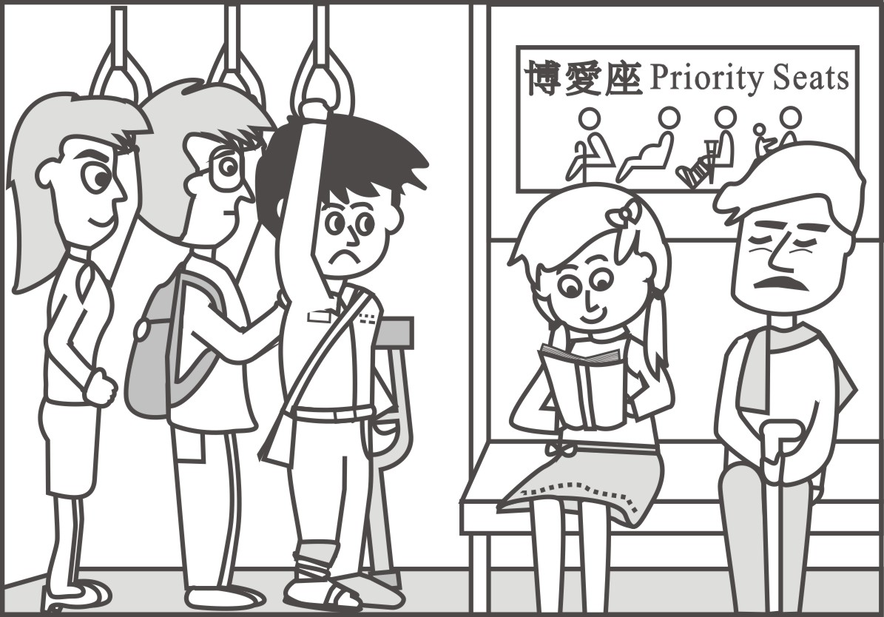

1

2

3

4

*2.文長須分成兩段，****至少160個單詞(words)****。*

*提示：請仔細觀察以下三幅連環圖片的內容，並想像第四幅圖片可能的發展，寫出一個涵蓋連環圖片內容並有完整結局的故事。*

* **Key information:**
* Who were involved in the story?
* Where and when did the story occur?
* What happened to the characters in the story?
* How did they response to this situation?
* Why do you tell such a story?

|  |
| --- |
| * 請利用這次暑期輔導所共同參與的作文翻譯課程，同時展現你的誠意和現有寫作能力，在看完以上的四格連環圖，將下列不完整而零散的段落，書寫成一段有意義的故事內容。   1st Paragraph  In retrospect of my junior high school life, I still remember......................................................  ......When I *got* on the MRT, I *looked* around to find any available seat..................It *was* a priority seat, but I still *decided* to sit down. While I *was*..........., an elderly man *got* on the MRT..........His legs *were* trembling............................................................................................................................  ............................................................................................................................................................  2nd Paragraph  In the next morning,.............................I *hobbled* arduously and *got* on the MRT. I *was* so helpless because all the seats *were* occupied. As a result, I...............................................................  .....................................................................Finally,........................................................................... |

**(續背面)**