How to Make a Badge & Key Ring 如何做徽章和鑰匙圈
Materials(材料): scissors 剪刀 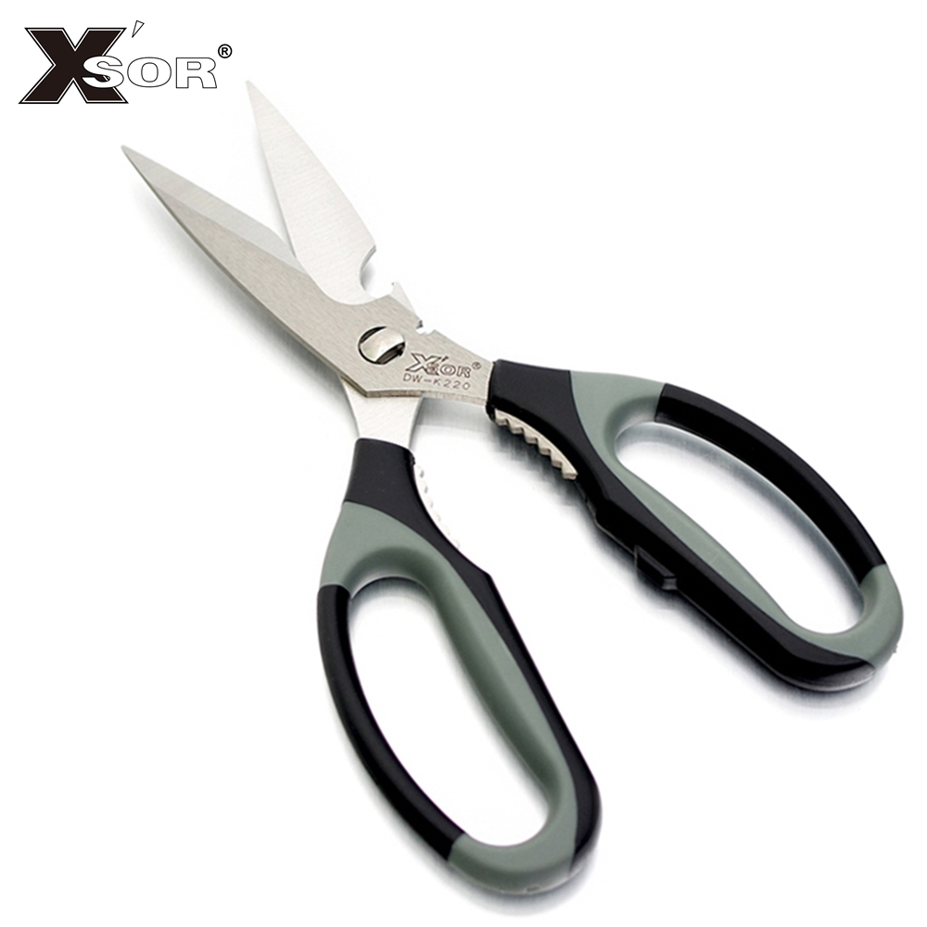 pliers 鉗子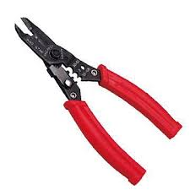 mirror 鏡子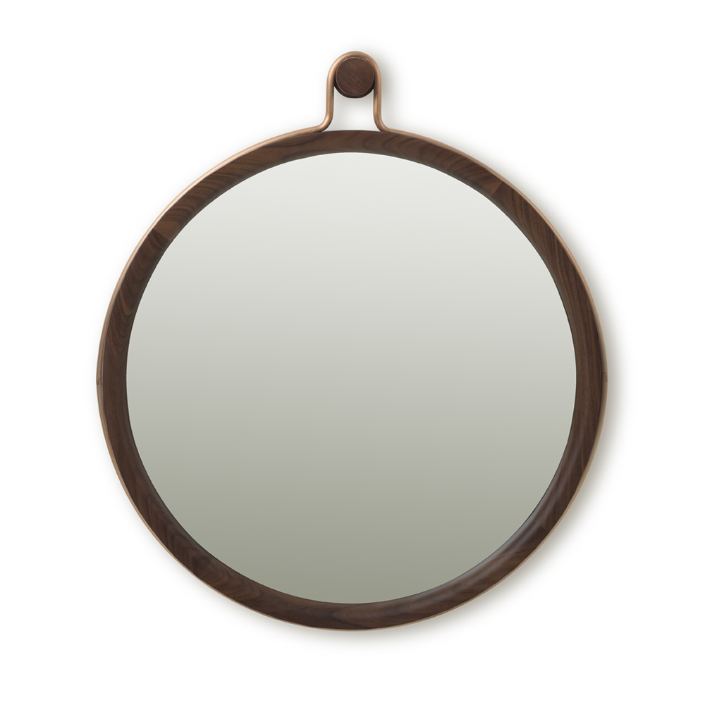
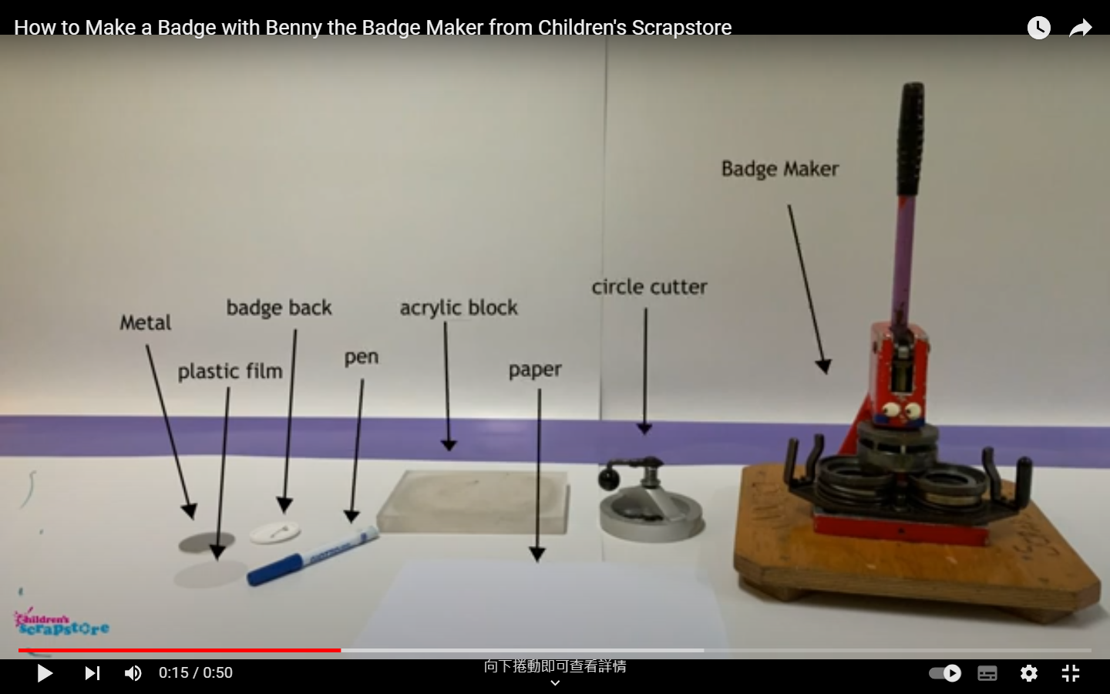
Steps (步驟):
- Cut out the circle. 剪圓圈
- Place the metal, paper, and plastic film into the machine. 把金屬片,紙,和塑膠膜放入機器。
- (place the concave side of the metal facing downward) 鐵片凹面朝下
- (Make sure the picture is facing towards you as the front side) 圖片請朝自己是正面
- (Put the plastic film on the picture and push the device to the right) 透明片放在圖上後，往右推
- Pull the handle down firmly. 用力向下拉手柄。
- Place the badge back in the machine, making sure the pin faces down. 將徽章放回機器中，確保別針面朝下。
→ Push the device to the left. 往左推
key ring: 4. The mirror side should be facing towards the front.鏡子這一面要扣著朝正面
There is a pointed part on the second track. Place it towards this hole with the mirror facing downward and push it over.第二個軌道有一個尖尖的地方朝著這個洞放下去，鏡面朝下，接著把它推過來。

- Pull the handle down firmly again. 再次用力向下拉手柄。

How to Make a Badge

Video: https://www.youtube.com/watch?v=3Yqwgi8NiWo (English version)
Yalin’s video: https://youtu.be/jD2aiEXp5OA


How to Make a Key Ring
Yalin’s video: https://youtu.be/tS6qqiLQ-sQ

