公開課英語教案設計
教學領域 | 英語 | 授課教師 |  | 高寶貴
教學版本 | Here we go 6 | 教學單元 |  | Whose backpack is that?
教學時間 | 共 1節，演示為40分鐘 | 演示日期 |  | 114年 5月 19日
教學對象分析 | 1.學生對動物所知甚多，但仍有部分需加以詳述讓學生了解。。  2.由於班上英文程度呈現兩極化現象。對於英文程度好的學生易於了解簡易的生詞。反之，剩餘同學易因於缺乏練習，而易混淆各個單詞及簡易句子的回答。  3.利用有趣的動物猜謎引起學生的學習動機。
教學總目標 | 運用生活周遭所用的日常用品聯想以學習新的字詞。
對 應  能力指標 | 英-E-B1  具備入門的聽、說、讀、寫英語文能力。在引導下，能運用所學、字詞及句型進行簡易日常溝通。
教學資源 | computer, ppt, pencil, marker.
教 學 活 動 |  |  | 時間 |  | 教學資源
第一節
【課堂活動】warm up  - The teacher will greet the students, remind them of the classroom rules.  - The teacher will sing “Brown bear brown bear what do you see?” to review the animals.  - Do the animal riddles’ guessing.  - The teacher will ask where does Rocky go?  【課堂活動】presentation  - Review new words: backpack, cap, lunchbox, umbrella, water bottle, workbook, glasses, shoes.  - Listen, read and spell:  - Let’s travel: introducing Kenya  The teacher quickly introduce the pictures of page 53 and do the Q and A first.  3-1 What animals do you see?  3-2 Where are they?  3-3 How many elephants are there?  3-4 What does Mia (Teddy, Amber, Rocky) have?  3-5 What do you need if you go to Kenya?  - Watch the film of Let’s travel.  - Introduce Kenya and have the short Q & A to ask how much do the students know about Kenya.  【課堂活動】Wrap up  - Play board games: country of Kenya  - Packing for a trip: What will you bring if you want to go to Kenya?  I am going to ________.  I need ________.  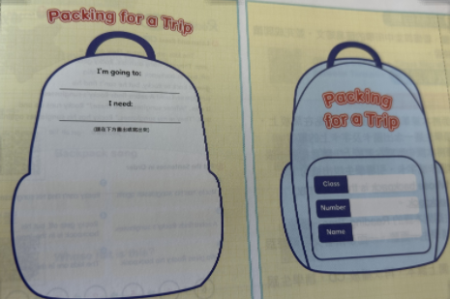 |  |  | 10 mins  5mins  15 mins  10mins |  | Flashcards, ppt, computer,  Cards of board game,  worksheet

