113歷屆試題 Class ______ No________ Name: _______________
One fine morning in 1941, Swiss engineer George de Mestral went for a walk in the woods with his dog. Upon their return home, he found a lot of burrs (from plants) stuck to the dog’s fur and his pants. He immediately rushed to his microscope and examined the burrs attached on his pants—feeling a lightbulb moment coming on.
Upon closer examination, de Mestral observed that the burrs, which appeared straight to the naked eye, actually contained many small hooks that clung firmly to the loops in the fabric of his pants. He determined that if he could recreate the same thing, making hooks-and-loops that bind to each other firmly, he could produce a strong fastener with many uses.
De Mestral’s first challenge was finding a fabric for a strong bonding system. He first tried cotton, but it proved too soft and could not withstand repeated openings and closures. After years of research and testing, he learned that synthetics worked best and eventually settled on heat-treated nylon, a strong and durable substance. By 1955, he had completed an improved version of the product, with each square inch of material containing 300 hooks, which made it stay fastened and yet easy enough to pull apart when needed. Named “Velcro,” from the French words velours (velvet) and crochet (hook), the new product received a patent from the Swiss government in 1955. De Mestral thus began mass-producing Velcro, opening plants in Europe and eventually into Canada and the United States.
Initially Velcro did not fare well. As most fashion critics considered it ugly and cheap-looking, the use of Velcro was limited to athletic equipment. In the early 1960s, the product received a huge boost in popularity when NASA began using it in a lot of equipment that went into space along with astronauts. Today, de Mestral’s design is found almost everywhere: clothing and footwear, toys, airline seat cushions, blood pressure cuffs and surgeons’ gowns. Most impressively, the magical fastener was used in the first human artificial heart transplantation to hold together parts of the device.
35. Which of the following pictures shows de Mestral’s invention?
(A)  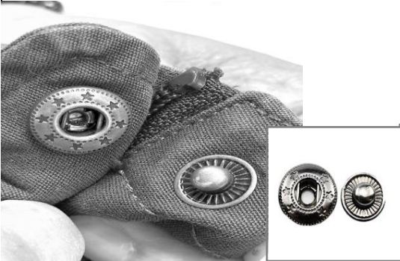 | (B)  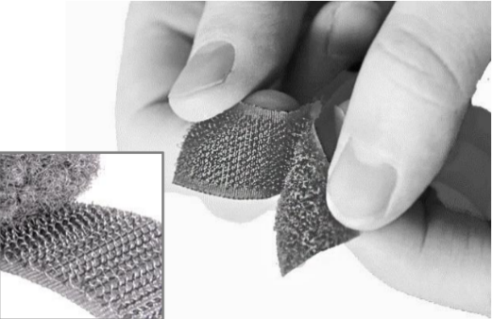
(C)  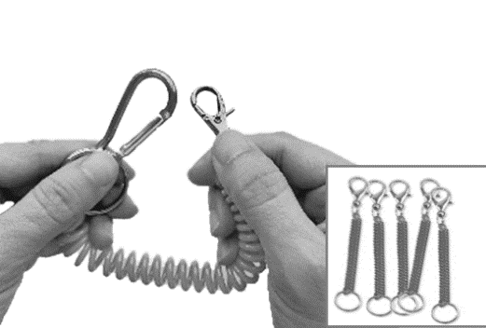 | (D)  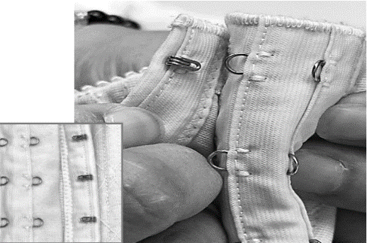

36. What does the author mean by “a lightbulb moment” in the first paragraph?
(A) A blessing in disguise.
(B) A happy ending.
(C) An unpredictable future.
(D) A sudden inspiration.
37. Which of the following statements about Velcro is true?
(A) It has been a market favorite since its first appearance.
(B) Cotton was not durable enough to be used as its materials.
(C) It was given a French name because it was first produced in France.
(D) The design was intended to look as shiny and smooth as velvet.
38. Which of the following fields is NOT mentioned for Velcro uses in the passage?
(A) Civil engineering.
(B) Aerospace industry.
(C) Medical technology.
(D) Sports and recreation.

109歷屆試題
Ships are the lifeline of trade among countries. Almost everything, from food to machinery, comes by way of the sea in huge ships piloted by captains. But the captain of a ship is responsible for guiding the vessel until they hit a port, waiting to enter the harbor. The task of bringing the ship into the harbor and anchoring it is taken up by a different captain. This captain is called a marine pilot.
A marine pilot is a boat pilot with specialized knowledge of a particular port or harbor. The pilot is needed to direct large ships into a port, where there are often deep water channels surrounded by shallower seabeds. Without the services of a marine pilot, docking ships would be hazardous. There would be a real chance of running aground and damaging the ship and the cargo, some of which might be dangerous if released into a water-based ecosystem.
In addition to the shallower seabeds, tide and wind pose further challenges for bringing ships into a port. During different tides, currents may change from one direction to the other. The same strategy for docking a vessel during an incoming tide may not work during an outgoing tide. Also, the wind can significantly alter the direction of the ship and how it reacts, adding to the difficulty of anchoring the ship.
Marine pilotage is a job that requires a high degree of proficiency as well as quick and independent thinking. Above all, it is about risk management. A marine pilot goes on board at a crucial time and controls the vessel based on his or her knowledge of the port and the situation at hand. The pilot is responsible for not only the safety of the ship but also the protection of the port and the marine environment.
45. What is the passage mainly about?
(A) A special profession. (B) Shipping and trading.
(C) Guidelines for safe docking. (D) Protection of the marine environment.
46. Which of the following is part of the knowledge that a marine pilot must have?
(A) The value of the ships. (B) The content of the cargo.
(C) The weather conditions. (D) The diversity of marine life.
47. What does “a crucial time” in the last paragraph refer to?
(A) When the vessel hits a flat. (B) When the channel is not deep enough.
(C) When there is a collision of two ships. (D) When a ship is waiting to enter the port.
48. How does the author conclude the passage in the last paragraph?
(A) By adding new details. (B) By predicting future development.
(C) By summarizing the main points. (D) By giving advice to the general public.

110指考試題
France gave birth to restaurants, but it was no civilized affair. In fact, today’s restaurant business is a byproduct of the class warfare that arose during the French Revolution.
Back in the Middle Ages, fine dining was a privilege enjoyed exclusively by noble families who had their own grand kitchens and personal chefs. The only commercial diners for the masses were dusty, shabby roadside inns, where strangers crowded around mediocre buffets of lukewarm roasts and over-sauced beans. But sometime in the 1760s, the merchant class of Paris developed a taste for healthy clear broths which were considered restorative; hence the term “restaurant.” By the 1780s, this new Parisian “healthy food” craze led to a handful of reputable dining halls, where customers could sit at individual tables and choose from a wide range of dishes.
Ironically, the popularity of these restaurants grew at a time when the majority of the French population could not afford bread. Decades of harsh winters and oppressive taxation had taken their toll on kitchen tables. By 1789, the starving French masses could no longer be controlled. Looting and riots erupted throughout Paris, ushering in the French Revolution. Rich nobles fled to the countryside, leaving behind their highly skilled chefs and the fine wines from their cellars. Suddenly, unemployed cooks found their way to the city’s eateries, and within a year, nearly 50 elegant restaurants had popped up in Paris.
The restaurant business truly came into its own during the early 1800s, after General Napoleon seized control of the country. He granted “freedom of pleasure” to all citizens, as he reasoned that people who were focused on champagne and fine food probably would not conspire against him. The number of restaurants rose quickly. By 1814, about three thousand restaurants were listed in a popular travel guide. Paris became the center of the new restaurant scene, which, to some degree, it remains today.
40. According to the passage, where does the word “restaurant” originate from?
(A) Famous chefs. (B) Popular soups. (C) Dining halls. (D) Daily menus.
41. What does “taken their toll on kitchen tables” mean in the third paragraph?
(A) Deprived people of adequate food for living.
(B) Controlled the nutrients in people’s diet.
(C) Charged people for using kitchen tables.
(D) Paid tribute to chefs working in kitchens.
42. Which of the following is true about commercial diners before the French Revolution?
(A) Many fine restaurants were owned by highly skilled chefs.
(B) Reputable dining halls were popular in Paris during the 1760s.
(C) Public dining halls in the Middle Ages were run-down and dirty.
(D) A limited variety of food was served in Parisian restaurants in the 1780s.
43. What was the main reason for Napoleon to promote the development of restaurants?
(A) He hoped to improve the life of his citizens.
(B) He wanted to help unemployed chefs find new jobs.
(C) He feared that reductions in restaurants might hurt the travel business.
(D) He believed that the development of restaurants would bring political stability.

109指考試題
Early civilizations often built drainage systems in urban areas to handle rainwater that ran down the street during a storm. The Romans constructed elaborate systems that also drained wastewater from the public baths. However, as the population of the cities grew, the old drainage systems became overloaded. During the Industrial Revolution, manufacturing waste was added to sewage, which increased the need for more efficient sewage treatment. In the mid-19th century, the first steps were taken to treat wastewater.
Sewage or wastewater treatment in modern times is the process of removing harmful physical, chemical, and biological elements from wastewater and house sewage. The whole process starts with screening out large objects such as paper and wood, and removing heavy materials like dirt. The screened wastewater is then ready to go through a series of concrete tanks for further treatment. In the second step, the sewage passes into the primary tanks. Here, human waste, called sludge, settles to the bottom while oils and grease float to the top, where they are collected. At the same time, organic matter like eggshells or coffee grounds in the sewage is broken down into smaller substances. The remaining sewage then enters the secondary tanks for the third stage of treatment. The solids that were not treated in the primary tanks are removed here through decomposition, which digests the material. Then, the liquid sewage is filtered through sand. This filtering process gets rid of almost all bacteria, as well as other solid particles that remain in the water. Finally, the wastewater flows into the last tanks, where the chemical chlorine is added to kill the remaining bacteria. After the bacteria are destroyed, the chlorine is eliminated from the water, and the treated clean water is discharged into a river or the ocean.
36. What is the passage mainly about?
(A) The elements of sewage. (B) The treatment of wastewater.
(C) The history of draining systems. (D) The ways to control manufacturing waste.
37. Which of the following is NOT a reason for developing more effective systems to deal with wastewater?
(A) Population growth. (B) Increasing manufacturing waste.
(C) Overloaded drainage systems. (D) Heavy rainfall due to climate change.
38. Which of the following can be removed in the primary tanks?
(A) Wood. (B) Heavy material. (C) Grease. (D) Organic matter.
39. What is the main reason that liquid sewage needs to go through sand?
(A) To eliminate bacteria. (B) To drain water.
(C) To dissolve solid particles. (D) To remove oil.

